Chris Watkins

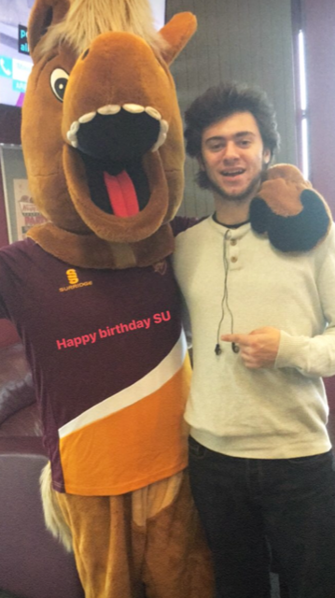
Intro:
I will try to keep this brief and straight to the point of my experience with the student’s union these past few years and what I can offer. Can I say however, if it was not for the student union and the services it provides, I would not have been able to surpass my first year given the difficulties I faced, and I hope to support offer students who face difficulties as I did, to further their aspirations in life. Which is what university can be all about. I have a board understanding of how the Student’s Union operates already due to my past experience working with the SU. I have sat on student council for two years, as an athletics union councillor and entertainments officer. I have been a member of the executive committee for one year also, alongside being a sports team committee member for 2 years.
1 Focus on Welfare on campus.
Provide a format for students to directly voice their concerns with problems on campus and the university directly to the union.
2 physical exercise.
Present exercise event opportunities and educational briefings. Also working with sports teams and societies to support physical health.
3 continue support for international students
Making sure international students are provided with adequate accommodation and the socialisation they require early on in their first academic year.
4 To provide support for liberation groups and their part-time officers.
I will provide support to fill in the gaps when part time officers struggle during such times of time constraint.
5 build upon a sense of community.
Give students a sense of priority and make them feel safe upon campus.

3 points for areas of interest:
Increased focus on physical well-being
Give the students the feeling of a safe community on campus
Increase and build upon relationships with the university for greater cooperation

