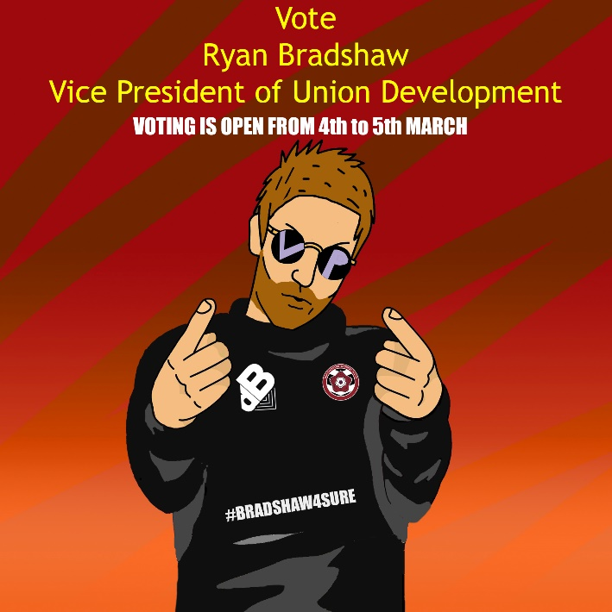

VPUD Manifesto
I am the current Vice president Union Development and I am looking to run for my second term in office. A couple of Key things I have achieved this year would be the SU Talks Brand and a brand new Refreshers Programme alongside many other initiatives to better the student experience for all.

Manifesto pledges
- Ensure Sports, Societies and Volunteering Groups remain FREE
- Encourage and support students undertaking employment and work experience opportunities.
- Launch at least 10 new Events that cater to the wide variety of Students.
- Raise awareness and challenge the stigma around mental health.

Areas of interest:
- Create a ‘Buzz’ on campus through activities and events.
- Encourage Participation and engagement in sports, societies and Volunteering.
- Focus on entertainments, events, activities, sports and Societies.

