Student Council Bye-Law Amendment Proposal (SCF1)

The Students’ Union constitution allows Student Council to amend bye-laws. The Constitution specifically states:

78. The Trustees and the Student Council shall have the power from time to time to jointly make, repeal or amend Bye-Laws as to the management of the Union and its working practices provided that such Bye-Laws shall not be inconsistent with this Constitution.

97.3 make, repeal and amend the Bye-Laws jointly with the Trustees in accordance with Clause 78;

Submission of this document (Student Council Bye-Law Amendment Proposal) to Student Council is a request for a change to the bye-laws.

INFORMATION REQUIRED
Please ensure the following details are completed before submission

- TITLE OF BYE-LAW AMENDMENT:- LGBT alliance
- NAME OF MASTER BYE-LAW TO BE AMENDED:- Committees
- FIRST PROPOSER
  - NAME:- Jonathon Vobe
  - SIGNATURE:-
  - DATE:- 25/04/2019
- SECOND PROPOSER
  - NAME:- Gemma Lovegrove
  - SIGNATURE:-
  - DATE:- 25/04/2019
- DATE MOTION WAS SUBMITTED TO CHAIR:-25/04/2019

MANDATE DETAILS

This Council Notes
State the facts surrounding the proposal

- There are a vast number of different groups within the LGBTQ+ communities
- Having only one person to represent all different demographics and allowing their views to be expressed is very difficult
- The NUSU Students council is having issues attaining quorum.
- This fact is making council less effective and thus a less effective union.
- The Lgbtq+ focus group held 22/03/2019 agreed with the idea of a sub committee on council, made up of different parts of the lgbtq+.
- It Is the council’s duty to hear the voice and will of the students, as well as to carry it out, where possible (in accordance with the uk law and NUSU constitution)
- Student feel that having a sub group will benefit overall engagement.
- Having more autonomy will provide a safer environment for students to be open about being themselves, and should provide a better overall support structure to these venerable students.

This Council Believes
State the reasons for amendment

A new sub-committee of council is to be formed.

The following amendments are to be made…

This Council Resolves

This council believes we should vote on the following.

The creation of a new sub-committee

The creation of a new email account (communication)

The creation of a new sage account (finance)

The addition to the bye-laws

The addition to the bye-law appendix

Old bye-law:

New bye-law:

5.7 Lesbian Gay Bisexual Transgender Plus Alliance (LGBT+ Alliance)

Definition of LGBT+ Alliance

5.7.1 LGBT+ Alliance members are members of the LGBT+ community as well as allies of these communities.

5.7.2 This committee is a collection of students who have responsibility for all issues that LGBT+ members face on behalf of Council.

5.7.2.1 The aim of the committee is to provide a support network and community which will improve the experience of LGBT+ members at the University of Northampton.

Electing LGBT+ Alliance committee members

5.7.3 The LGBT+ Alliance committee members are to be ratified via elections held in accordance with the NUSU elections bye-law, found on the NUSU website.

5.7.3.1 The following positions cannot be held by the LGBTQ+ officer or the Trans officer of the NUSU executive team… President, Secretary, treasurer, Aromatic & Asexual advocate, Transgender advocate, QTIPOC advocate, intersex advocate, LGB advocate, Other advocate.

5.7.3.2 The president of the LGBT+ Alliance cannot be the president of the LGBTQ+ society

Membership of the LGBT+ Alliance

5.7.4 The following are all available positions and role descriptions as appropriate.

5.7.4.1 President: The President will be responsible for ensuring all other members are completing their duties, will be responsible for holding and chairing monthly committee meetings (see appendix G), both the President of the NUSU and the LGBTQ+ officer must either attend or send apologies. The president of the LGBT+ Alliance is also responsible for ensuring the 3-year development plan is completed every 3 years and reviewed every year alongside all other committee members and the LGBT+ officer. The president will automatically hold one of the 4 councilor seats and must present the minutes of the LGBT+ alliance committee minutes to council.

5.7.4.2 Secretary: They will be responsible for minute taking for the committee meetings (see appendix G). The will also be responsible for booking rooms as and when required. They also need to send the minutes of the committee meeting to council. They alongside the President need to make sure that any agenda items are distributed to the LGBT+ Alliance committee members at least 3 working days before the meeting.

5.7.4.3 Treasurer: Responsible for all actions regarding money such as applying for funding, ensuring the LGBT+ Alliance does not run out of funds etc.

5.7.4.4 Collaborations Organizer: responsible for organizing at least 4 social events in the academic year that collaborate with other existing groups in the SU (excluding the LGBTQ+ society) this can include but not exclusive to: societies, sports clubs; volunteering projects and fellow sub-committees.

5.7.4.5 Aromatic & Asexual advocate: Will be responsible for gathering the views of the aromatic and asexual communities and expressing them.

5.7.4.6 Transgender advocate: Will be responsible for gathering the views of the transgender communities and expressing them.

5.7.4.7 QTIPOC advocate: Will be responsible for gathering the views of the Queer Transgender and Intersex People Of Colour communities and expressing them.

5.7.4.8 intersex advocate: Will be responsible for gathering the views of the intersex communities and expressing them.

5.7.4.9 LGB advocate: Will be responsible for gathering the views of the gay, lesbian and bisexual communities and expressing them.

5.7.4.10 Other advocate: Will be responsible for gathering the views communities within the alliance not currently defined by other roles and expressing them.

Removing LGBT+ Alliance Committee Members

5.7.5. LGBT+ Alliance committee members may only be removed from position under one of the following circumstances:

5.7.5.1. Disciplinary decision governed by disciplinary bye-law.

5.7.5.2. Vote of no confidence at an emergency members meeting called by any member of the LGBT+ Alliance.

5.7.5.3. Failure to attend 3 LBGT+ Alliance committee meetings in an academic year, without submitting apologies.

5.7.6. A LGBT+ Alliance committee member can appeal their vote of no confidence to the chair of Student Council, in writing, within 10 working days.

5.7.7. For a vote of no confidence decision to be overturned, a simple majority at student council must be achieved.

LGBT+ Alliance Committee Regulations

5.7.8. See the Terms of Reference at Appendix G of this bye-law

General Regulations for Committees

5.7.9. Committees are required to abide by the Constitution and Bye-laws of UNSU, and the Mission, Values, Policies, Regulations and Procedures adopted by Student Council and the Board of Trustees.

5.7.10. All elected Committee positions will expire at midnight on 31st March, with new roles taking over on 1st April.

5.7.10.1 All roles will be advertised from February 1st at the latest.

5.7.10.2 Any roles not filled will be included in the October bye election period.

5.7.10.3 Any role not filled in both the main election and the bye-election may be filled using the elections bye-laws sections 2.3 and all of 2.4.

5.6.11 LGBT+ Alliance committee members are responsible for holding meetings with all of the members from the LGBT+ Alliance.

Appendix

LGBT+ Alliance Terms of Reference

The purpose of the LGBT+ Alliance Committee forum will be to: -

1. Ensure that all LBGT+ Students have a representation within the Students’ Union democratic process.

2. Communicate their decision to students, ensuring the group is seen to be transparent and democratic in all its decision-making.

3. To discuss matters relating to LGBT+ Alliance, ensuring that the SU administers and supports the LGBT+ Alliance in a fair and efficient way.

The LGBT+ Alliance, Committee: -

4. Will consist of the following members:
4.1. Elected Student Chair, (automatically the LGBT+ Alliance president)
4.2. Elected Student Vice-Chair
4.3. Elected Student Minute taker, (automatically the LGBT+ Alliance secretary)
4.4. Remaining committee members
4.5. LGBTQ+ Officer
4.6 President of the students’ union
4.7 President of any group that sits beneath the Alliance

5. The following staff are able to be invited to support the committee in a non-voting, advisory capacity.
5.1. Advocacy manager
5.2. Advocacy Coordinator
5.3 Other Sabbatical officer and part time officers.
5.4. Anybody else that the chair deems appropriate to that meeting

6. Will be and shall be chaired by the Student Chair, and in his/her absence by the student Vice-Chair.

7. Student Chair, Vice-Chair and Secretary are to be elected from democratic methods, this includes the main and by-election of the LGBT+ Alliance, as well as a vote during forum for remaining positions.

8. Will meet in accordance with the committee by-law 5.7.4.1, once per month.

9. Is accountable to the Student Council and must provide reports for every meeting.

Voting
8. The usual voting options are: Yes, No and Abstain.

9. At any meeting each member is eligible to participate in the LGBT+ Alliance Committee will have a maximum of one voting/ratification card should they be required at the meeting.

10. quoracy is set to be 50% of positions filled as per section 4. With the minimum set as 3.

11. Any vote taken will pass with a simple majority unless the vote is to make changes to this document, when a two-thirds majority will be required.

Regular Business
12. Approval of last minutes

13. To discuss the development of current and future projects within the Students’ Union:

14. To review, question and vote on reports given by each Officer.

15. To produce recommendations to Student Council

16. To approve new projects.

17. Any other business

Annual business

18. reviewal of the 3-year plan

19. Electing committee members to be councillors

20. Collate and submit annual report to Student Council.

Members of the LGBT+ Alliance Committee will: -

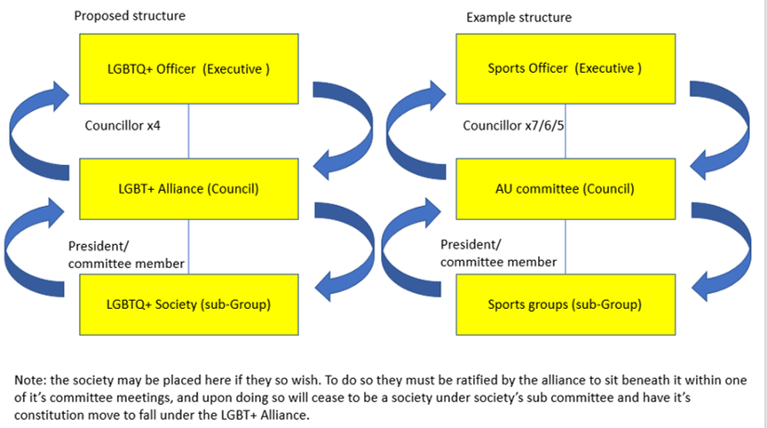
21. Prepare for each meeting fully, being active and be able to contribute to the discussion

22. Agenda will be sent around no less than 72 hours in advance of the meeting. It is the responsibility of the relevant committee members to submit discussion topic to the chair in advance of this deadline.

23. Minutes will be distributed no later than 48 hours following the meeting.

Appendix B

