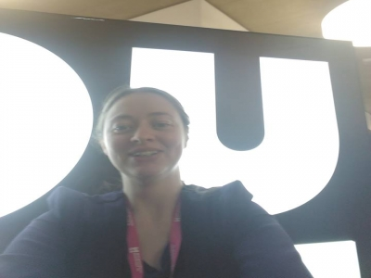
Hello! My name is Catriona Doyle, 1st year Podiatry student. One of the reasons I chose University of Northampton for my studies is because of our passionate and vibrant Students Union. Despite turning down an offer to study here in 2015, I still followed the work of the Union online. Having a musculoskeletal health problem in late 2015 has turned out alright as I really wanted to continue with the course I had started back in Northern Ireland after receiving treatment but in a new environment. The decision to reapply to this university has I believe been the right choice. As soon as any opportunity to get involved in the democracy or advocacy side of the union came up, I went for it. I wish to continue my involvement in the Union so have decided to run for Disabled Officer.

Manifesto Points
#1 As a student with a learning disability, I am aware of the extra challenges we face during our studies. I want to become aware of the challenges faced by students with other disabilities to best support them and have their interests and concerns in mind when attending officer meetings.
#2 I also want to establish meet-ups between disabled students to share strategies on how manage a disability whilst at uni. A part of this would include helping to set up a disabled students society which I have seen some students would like to have.
#3 I wish to liaise with other part-time officers. A disabled student may also be LGBTQ+ and/or a mature student. I would point the disabled student in the right direction if they wished to chat to someone or get involved in, for instance, mature student events.

General areas of interest
#1 Tackling stress- the added pressure of having a disability and studying can be stressful. I believe that simple ways of relieving stress can be effective such as adult colouring or neurolinguistic programming techniques (the study of how humans can achieve excellence) or picking up a musical instrument or sports ball (any sport).
#2 Promoting the work of the Union- It’s great to see so many students involved in the Union. I would like to use my social media platform if elected to encourage students to get involved. I would like to do 'campus dashes' to tell others about the Union during peak periods in our university buildings.
#3 Volunteering- As a volunteer at Parkrun, I enjoy meeting other people and having a good time whilst benefiting a good cause. I would like to organise a 'take-over' at Parkrun at the racecourse where all volunteers are from the university.

