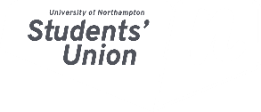

November 29th Trustee Report

December 2018 Student Council

Rafael Garcia-Krailing

Summary
The board of trustees met on the 29th of November

Here is a brief bullet point account of the meeting.

A more comprehensive report shall be released once the minutes have been completed.

Bullet point Report
- Completed all Actions on Action List
- Update on Student Numbers
- Finished Strategic Plan Showcase
- Bye Elections Update
- Reviewed and Passed all Amendments to Terms of References
- Audited accounts approved
- VP BME Proposal Approved
- CEO Key Performance Indicators approved
- Approval of SU Talks Budget
- Approval of Risk Register
- CEO Report
- Charitable Services Report

