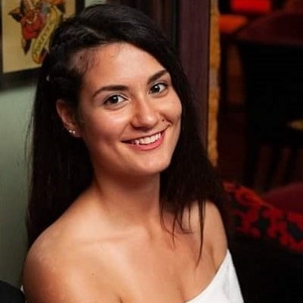

Recently changemaker team competed with a really big success its first big lunch event! People were so exited about it. They met new people, danced, singed, ate and did many more activities. I was a part of the team that made this idea come true, and the way that I felt when I saw people smiling can not be explained. This is the main reason why I chose this position.

I want people to get more involved in the society, make new friends, explore their skills and make a change in the world.
These would be achieved through volunteering, events, trips and cooperation with the Changemaker Hub and the societies.

